ADVANCE DATABASE MANGEMENT SYSTEM PROJECT FOR
STOCK MARKET



BY
HIRAL SHAH
PRAJAKTA SHINDE

TABLE OF CONTENTS

SR. NO. | TOPIC
1 | PROBLEM STATMENT
2 | ER DIAGRAM
3 | RELATIONAL DAIGRAM
4 | SNAPSHOT & CODE
5 | BACK END CODE

PROBLEM STATMENT

Most major corporations are publicly owned. Companies offer shares of ownership called stock. The price of stock changes by the minute depending on the value investors place on the stock. Corporations sell stock to raise money and grow the business.
A share is a single unit of ownership in a corporation. A shareholder, also known as a stockholder, is a person who owns shares of a certain company or organization, and is thus a part-owner of the company. If there are a million shares and you own 1000, you own 0.001 of the company. As owners, the holders are entitled to elect the directors of the corporation and vote on major issues. These votes typically take place at the corporation’s annual meeting, which shareholders are invited to attend.
In the fascinating world of stock market millions of transactions take place at every second. The aim of this project is to maintain a database system consisting of the information about the current state of stock market.
Every company has its name, industry to which it belongs, total number of shares it holds and current price of its shares. Every user (shareholder) has its name and unique id. Also different currencies and commodities are specified with their current prices.

RELATIONAL SCHEMA

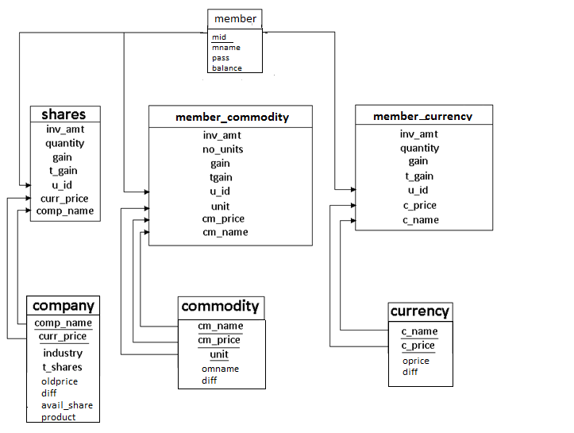

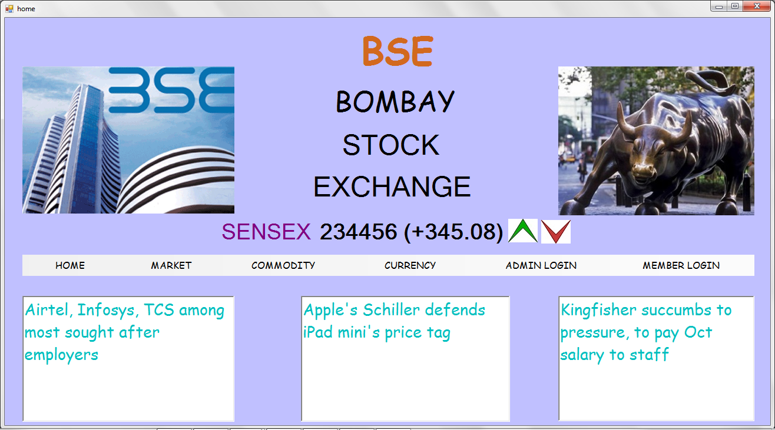

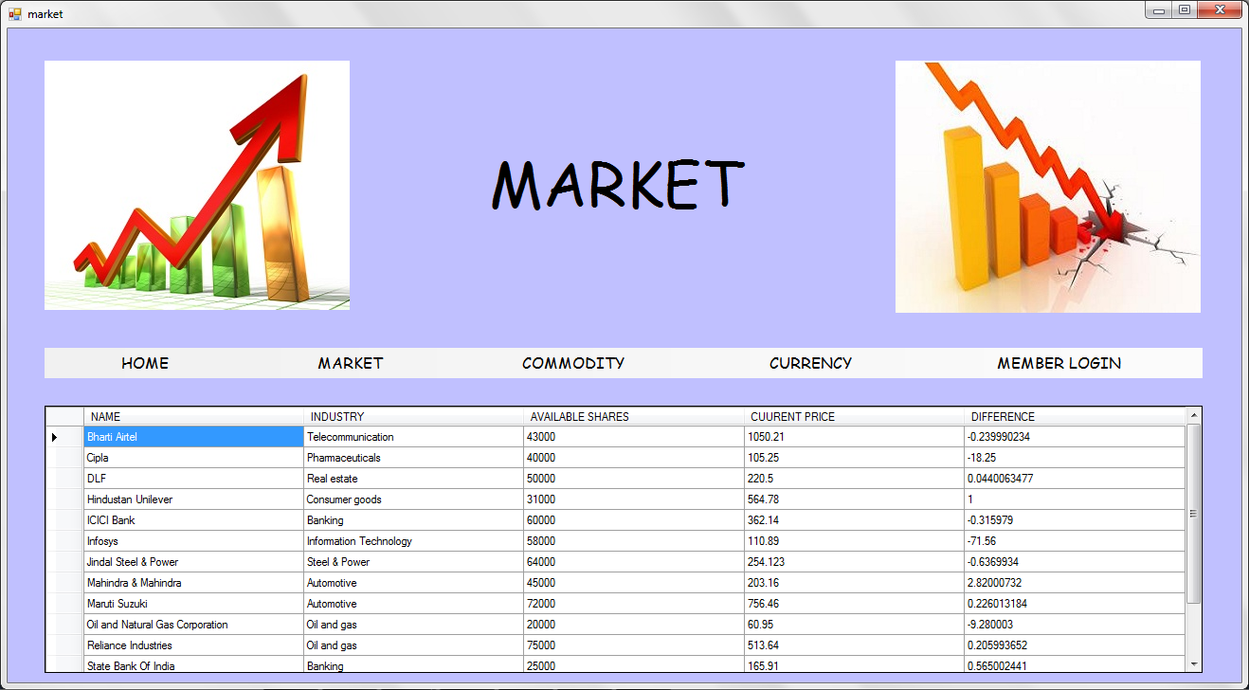

Imports System.Data.SqlClient

Public Class market
Dim myconn As SqlConnection
Dim mycom As SqlCommand
Dim mycom1 As SqlCommand
Dim da As SqlDataAdapter
Dim ds As DataSet
Dim dt As DataTable
Dim db As BindingSource
Dim sb As SqlCommandBuilder

Private Sub market_Load(ByVal sender As System.Object, ByVal e As System.EventArgs) Handles MyBase.Load
Try
myconn = New SqlConnection("Data Source=.;AttachDbFilename=C:\Program Files (x86)\Microsoft SQL Server\MSSQL10_50.MSSQLSERVER\MSSQL\DATA\stockmarket.mdf;Integrated Security=True;Connect Timeout=30;User Instance=True")
myconn.Open()
mycom1 = New SqlCommand("update company set diff=curr_price-old_price", myconn)
mycom1.ExecuteNonQuery()
mycom = New SqlCommand("select * from comp", myconn)
da = New SqlDataAdapter("select * from comp", "Data Source=.;AttachDbFilename=C:\Program Files (x86)\Microsoft SQL Server\MSSQL10_50.MSSQLSERVER\MSSQL\DATA\stockmarket.mdf;Integrated Security=True;Connect Timeout=30;User Instance=True")
sb = New SqlCommandBuilder(da)
dt = New DataTable
da.Fill(dt)
db.DataSource = dt
market1.AutoResizeColumns(DataGridViewAutoSizeColumnsMode.AllCellsExceptHeader)
market1.ReadOnly = True
market1.DataSource = db
Catch ex As Exception
End Try
market1.AutoGenerateColumns = False
market1.ReadOnly = True
market1.Columns.AddRange(New DataGridViewTextBoxColumn(), New DataGridViewTextBoxColumn(), New DataGridViewTextBoxColumn(), New DataGridViewTextBoxColumn(), New DataGridViewTextBoxColumn())

market1.Columns(0).DataPropertyName = "comp_name"
market1.Columns(0).ReadOnly = True
market1.Columns(0).Name = "NAME"

market1.Columns(1).DataPropertyName = "industry"
market1.Columns(1).ReadOnly = True
market1.Columns(1).Name = "INDUSTRY"

market1.Columns(2).DataPropertyName = "avail_shares"
market1.Columns(2).ReadOnly = True
market1.Columns(2).Name = "AVAILABLE SHARES"

market1.Columns(3).DataPropertyName = "curr_price"
market1.Columns(3).ReadOnly = True
market1.Columns(3).Name = "CUURENT PRICE"

market1.Columns(4).DataPropertyName = "diff"
market1.Columns(4).ReadOnly = True
market1.Columns(4).Name = "DIFFERENCE"

market1.DataSource = dt

myconn.Close()

End Sub

Private Sub HOMEToolStripMenuItem_Click(ByVal sender As System.Object, ByVal e As System.EventArgs) Handles HOMEToolStripMenuItem.Click
Me.Hide()
home.Show()

End Sub

Private Sub COMMODITYToolStripMenuItem_Click(ByVal sender As System.Object, ByVal e As System.EventArgs) Handles COMMODITYToolStripMenuItem.Click
Me.Hide()
commodities.Show()

End Sub

Private Sub CURRENCYToolStripMenuItem_Click(ByVal sender As System.Object, ByVal e As System.EventArgs) Handles CURRENCYToolStripMenuItem.Click
Me.Hide()
currencies.Show()

End Sub

Private Sub MEMBERLOGINToolStripMenuItem_Click(ByVal sender As System.Object, ByVal e As System.EventArgs) Handles MEMBERLOGINToolStripMenuItem.Click
Me.Hide()
memlogin.Show()

End Sub

Private Sub MARKETToolStripMenuItem_Click(ByVal sender As System.Object, ByVal e As System.EventArgs) Handles MARKETToolStripMenuItem.Click

End Sub

Private Sub market1_CellContentClick(ByVal sender As System.Object, ByVal e As System.Windows.Forms.DataGridViewCellEventArgs) Handles market1.CellContentClick

End Sub
End Class

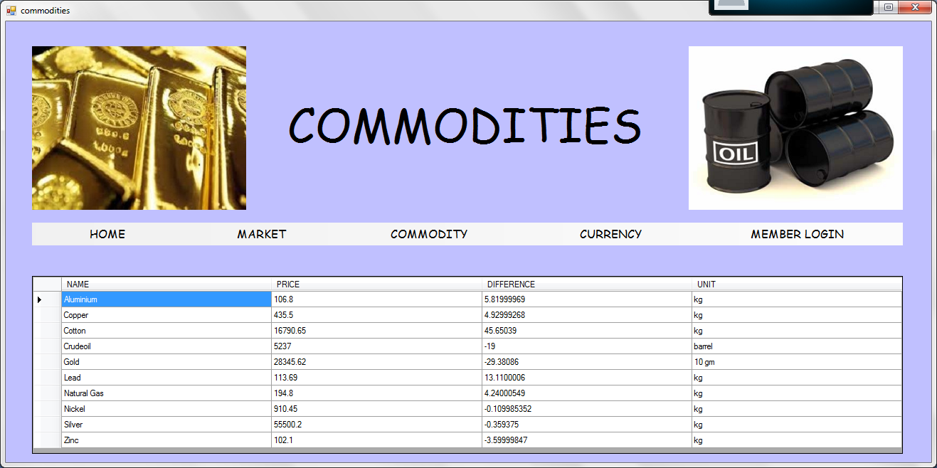

Imports System.Data.SqlClient

Public Class commodities

Dim myconn As SqlConnection
Dim mycom As SqlCommand
Dim da As SqlDataAdapter
Dim ds As DataSet
Dim mycom1 As SqlCommand
Dim dt As DataTable
Dim db As BindingSource
Dim sb As SqlCommandBuilder
Private Sub HOMEToolStripMenuItem_Click(ByVal sender As System.Object, ByVal e As System.EventArgs) Handles HOMEToolStripMenuItem.Click
Me.Hide()
home.Show()

End Sub

Private Sub MARKETToolStripMenuItem_Click(ByVal sender As System.Object, ByVal e As System.EventArgs) Handles MARKETToolStripMenuItem.Click
Me.Hide()
market.Show()

End Sub

Private Sub COMMODITYToolStripMenuItem_Click(ByVal sender As System.Object, ByVal e As System.EventArgs) Handles COMMODITYToolStripMenuItem.Click

End Sub

Private Sub CURRENCYToolStripMenuItem_Click(ByVal sender As System.Object, ByVal e As System.EventArgs) Handles CURRENCYToolStripMenuItem.Click
Me.Hide()
currencies.Show()

End Sub

Private Sub MEMBERLOGINToolStripMenuItem_Click(ByVal sender As System.Object, ByVal e As System.EventArgs) Handles MEMBERLOGINToolStripMenuItem.Click
Me.Hide()
memlogin.Show()

End Sub

Private Sub commodities_Load(ByVal sender As System.Object, ByVal e As System.EventArgs) Handles MyBase.Load
Try
myconn = New SqlConnection("Data Source=.;AttachDbFilename=C:\Program Files (x86)\Microsoft SQL Server\MSSQL10_50.MSSQLSERVER\MSSQL\DATA\stockmarket.mdf;Integrated Security=True;Connect Timeout=30;User Instance=True")
myconn.Open()
mycom1 = New SqlCommand("update commodity set diff=cmprice-oprice", myconn)
mycom1.ExecuteNonQuery()

mycom = New SqlCommand("select * from commodity", myconn)
da = New SqlDataAdapter("select * from commodity", "Data Source=.;AttachDbFilename=C:\Program Files (x86)\Microsoft SQL Server\MSSQL10_50.MSSQLSERVER\MSSQL\DATA\stockmarket.mdf;Integrated Security=True;Connect Timeout=30;User Instance=True")
sb = New SqlCommandBuilder(da)
dt = New DataTable

da.Fill(dt)
db.DataSource = dt

commodities1.AutoResizeColumns(DataGridViewAutoSizeColumnsMode.AllCellsExceptHeader)

commodities1.ReadOnly = True

commodities1.DataSource = db
Catch ex As Exception
End Try
commodities1.AutoGenerateColumns = False
commodities1.ReadOnly = True
commodities1.Columns.AddRange(New DataGridViewTextBoxColumn(), New DataGridViewTextBoxColumn(), New DataGridViewTextBoxColumn(), New DataGridViewTextBoxColumn())

commodities1.Columns(0).DataPropertyName = "cmname"
commodities1.Columns(0).ReadOnly = True
commodities1.Columns(0).Name = "NAME "

commodities1.Columns(1).DataPropertyName = "cmprice"
commodities1.Columns(1).ReadOnly = True
commodities1.Columns(1).Name = "PRICE"
commodities1.Columns(2).DataPropertyName = "diff"
commodities1.Columns(2).ReadOnly = True
commodities1.Columns(2).Name = "DIFFERENCE"
commodities1.Columns(3).DataPropertyName = "unit"
commodities1.Columns(3).ReadOnly = True
commodities1.Columns(3).Name = "UNIT"
commodities1.DataSource = dt
myconn.Close()

End Sub
End Class
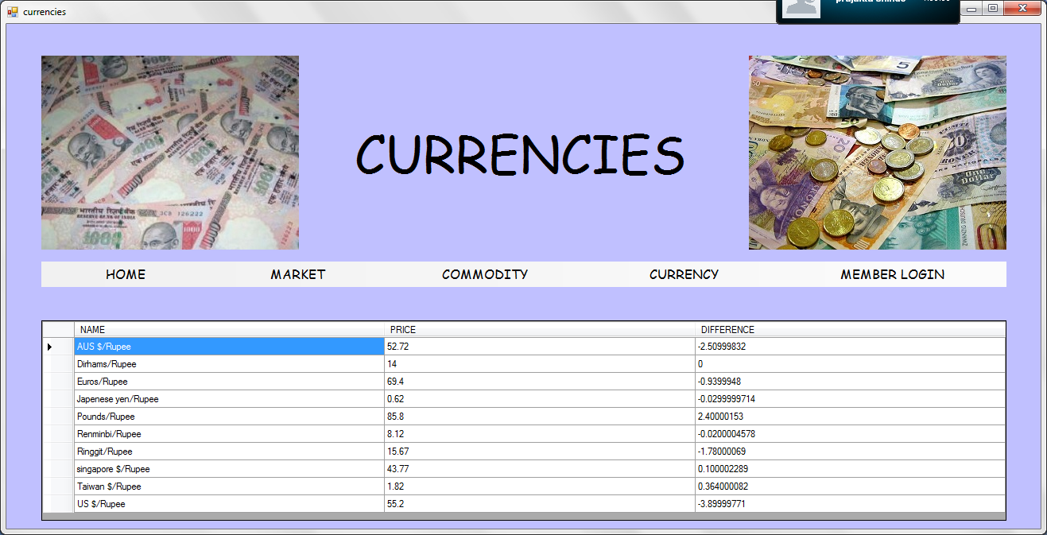

Imports System.Data.SqlClient

Public Class currencies

Dim myconn As SqlConnection
Dim mycom As SqlCommand
Dim mycom1 As SqlCommand

Dim da As SqlDataAdapter
Dim ds As DataSet
Dim dt As DataTable
Dim db As BindingSource
Dim sb As SqlCommandBuilder

Private Sub currencies_Load(ByVal sender As System.Object, ByVal e As System.EventArgs) Handles MyBase.Load
Try
myconn = New SqlConnection("Data Source=.;AttachDbFilename=C:\Program Files (x86)\Microsoft SQL Server\MSSQL10_50.MSSQLSERVER\MSSQL\DATA\stockmarket.mdf;Integrated Security=True;Connect Timeout=30;User Instance=True")
myconn.Open()
mycom1 = New SqlCommand("update currency set diff=cprice-oprice", myconn)
mycom1.ExecuteNonQuery()
mycom = New SqlCommand("select * from currency", myconn)
da = New SqlDataAdapter("select * from currency", "Data Source=.;AttachDbFilename=C:\Program Files (x86)\Microsoft SQL Server\MSSQL10_50.MSSQLSERVER\MSSQL\DATA\stockmarket.mdf;Integrated Security=True;Connect Timeout=30;User Instance=True")
sb = New SqlCommandBuilder(da)
dt = New DataTable

da.Fill(dt)
db.DataSource = dt

currencies1.AutoResizeColumns(DataGridViewAutoSizeColumnsMode.AllCellsExceptHeader)

currencies1.ReadOnly = True

currencies1.DataSource = db
Catch ex As Exception
End Try
currencies1.AutoGenerateColumns = False
currencies1.ReadOnly = True
currencies1.Columns.AddRange(New DataGridViewTextBoxColumn(), New DataGridViewTextBoxColumn(), New DataGridViewTextBoxColumn())

currencies1.Columns(0).DataPropertyName = "cname"
currencies1.Columns(0).ReadOnly = True
currencies1.Columns(0).Name = "NAME"

currencies1.Columns(1).DataPropertyName = "cprice"
currencies1.Columns(1).ReadOnly = True
currencies1.Columns(1).Name = "PRICE"

currencies1.Columns(2).DataPropertyName = "diff"
currencies1.Columns(2).ReadOnly = True
currencies1.Columns(2).Name = "DIFFERENCE"

currencies1.DataSource = dt

myconn.Close()

End Sub

Private Sub HOMEToolStripMenuItem_Click(ByVal sender As System.Object, ByVal e As System.EventArgs) Handles HOMEToolStripMenuItem.Click
Me.Hide()
home.Show()

End Sub

Private Sub MARKETToolStripMenuItem_Click(ByVal sender As System.Object, ByVal e As System.EventArgs) Handles MARKETToolStripMenuItem.Click
Me.Hide()
market.Show()

End Sub

Private Sub COMMODITYToolStripMenuItem_Click(ByVal sender As System.Object, ByVal e As System.EventArgs) Handles COMMODITYToolStripMenuItem.Click
Me.Hide()
commodities.Show()

End Sub

Private Sub MEMBERLOGINToolStripMenuItem_Click(ByVal sender As System.Object, ByVal e As System.EventArgs) Handles MEMBERLOGINToolStripMenuItem.Click
Me.Hide()
memlogin.Show()

End Sub

Private Sub CURRENCYToolStripMenuItem_Click(ByVal sender As System.Object, ByVal e As System.EventArgs) Handles CURRENCYToolStripMenuItem.Click

End Sub
End Class
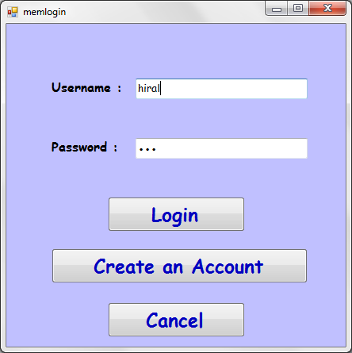

Imports System.Data.SqlClient

Public Class memlogin

Dim myconn As SqlConnection
Dim mycom As SqlCommand
Dim dr As SqlDataReader

Private Sub Button1_Click(ByVal sender As System.Object, ByVal e As System.EventArgs) Handles Button1.Click
Me.Hide()
add_acc.Show()

End Sub

Private Sub Button4_Click(ByVal sender As System.Object, ByVal e As System.EventArgs) Handles Button4.Click
Try
myconn = New SqlConnection("Data Source=.;AttachDbFilename=C:\Program Files (x86)\Microsoft SQL Server\MSSQL10_50.MSSQLSERVER\MSSQL\DATA\stockmarket.mdf;Integrated Security=True;Connect Timeout=30;User Instance=True")
myconn.Open()
mycom = New SqlCommand("select * from member where mname='" & TextBox1.Text & "' and pass='" & TextBox2.Text & "'", myconn)
dr = mycom.ExecuteReader()
If (dr.Read) Then

Me.Hide()
memdata.Show()
Else
MsgBox("INVALID USER CREDENTIALS")
End If
dr.Close()
myconn.Close()
Catch ex As Exception

End Try

End Sub

Private Sub Button2_Click(ByVal sender As System.Object, ByVal e As System.EventArgs) Handles Button2.Click
Me.Hide()
home.Show()

End Sub
End Class

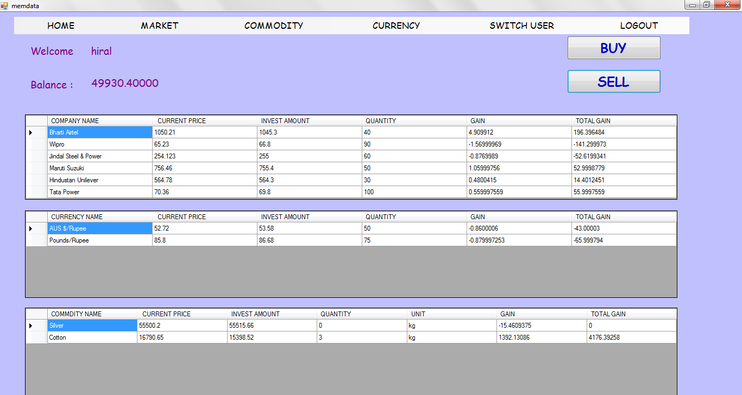

Imports System.Data.SqlClient

Public Class memdata

Dim myconn As SqlConnection
Dim mycom As SqlCommand
Dim mycom1 As SqlCommand
Dim mycom2 As SqlCommand
Dim mycom3 As SqlCommand
Dim mycom4 As SqlCommand
Dim mycom5 As SqlCommand
Dim mycom6 As SqlCommand
Dim mycom7 As SqlCommand
Dim dr As SqlDataReader
Dim user As String
Dim da As SqlDataAdapter
Dim ds As DataSet
Dim dt As DataTable
Dim db As BindingSource
Dim sb As SqlCommandBuilder
Private Sub HOMEToolStripMenuItem_Click(ByVal sender As System.Object, ByVal e As System.EventArgs) Handles HOMEToolStripMenuItem.Click
Me.Hide()
home.Show()

End Sub

Private Sub MARKETToolStripMenuItem_Click(ByVal sender As System.Object, ByVal e As System.EventArgs) Handles MARKETToolStripMenuItem.Click
Me.Hide()
market.Show()

End Sub

Private Sub COMMODITYToolStripMenuItem_Click(ByVal sender As System.Object, ByVal e As System.EventArgs) Handles COMMODITYToolStripMenuItem.Click
Me.Hide()
commodities.Show()

End Sub

Private Sub CURRENCYToolStripMenuItem_Click(ByVal sender As System.Object, ByVal e As System.EventArgs) Handles CURRENCYToolStripMenuItem.Click
Me.Hide()
currencies.Show()

End Sub

Private Sub SWITCHUSERToolStripMenuItem_Click(ByVal sender As System.Object, ByVal e As System.EventArgs) Handles SWITCHUSERToolStripMenuItem.Click
Me.Hide()
memlogin.Show()

End Sub

Private Sub LOGOUTToolStripMenuItem_Click(ByVal sender As System.Object, ByVal e As System.EventArgs) Handles LOGOUTToolStripMenuItem.Click
Me.Hide()
home.Show()

End Sub

Private Sub buy_Click(ByVal sender As System.Object, ByVal e As System.EventArgs) Handles buy1.Click
Me.Hide()
buy.Show()

End Sub

Private Sub sell_Click(ByVal sender As System.Object, ByVal e As System.EventArgs) Handles sell1.Click
Me.Hide()
sell.Show()

End Sub

Private Sub memdata_Load(ByVal sender As System.Object, ByVal e As System.EventArgs) Handles MyBase.Load
user = memlogin.TextBox1.Text
username.Text = user
Try

Me.Refresh()
myconn = New SqlConnection("Data Source=.;AttachDbFilename=C:\Program Files (x86)\Microsoft SQL Server\MSSQL10_50.MSSQLSERVER\MSSQL\DATA\stockmarket.mdf;Integrated Security=True;Connect Timeout=30;User Instance=True")
myconn.Open()
mycom1 = New SqlCommand("update member_currency set gain=cprice-invest_amt", myconn)
mycom1.ExecuteNonQuery()
mycom2 = New SqlCommand("update member_currency set tgain=gain*quantity", myconn)
mycom2.ExecuteNonQuery()
mycom3 = New SqlCommand("update member_commodity set gain=cmprice-invest_amt", myconn)
mycom3.ExecuteNonQuery()
mycom4 = New SqlCommand("update member_commodity set tgain=gain*quantity", myconn)
mycom4.ExecuteNonQuery()
mycom5 = New SqlCommand("update shares set gain=curr_price-invest_amt", myconn)
mycom5.ExecuteNonQuery()
mycom6 = New SqlCommand("update shares set tgain=gain*quantity", myconn)
mycom6.ExecuteNonQuery()
mycom7 = New SqlCommand("select balance from member where mname='" & user & "'", myconn)
dr = mycom7.ExecuteReader()
If (dr.Read) Then
balance.Text = dr.Item("balance")
End If
dr.Close()
myconn.Close()
Catch ex As Exception
End Try
Try
myconn = New SqlConnection("Data Source=.;AttachDbFilename=C:\Program Files (x86)\Microsoft SQL Server\MSSQL10_50.MSSQLSERVER\MSSQL\DATA\stockmarket.mdf;Integrated Security=True;Connect Timeout=30;User Instance=True")
myconn.Open()
mycom = New SqlCommand("select * from shares where mid in (select mid from member where mname='" & user & "')", myconn)
da = New SqlDataAdapter("select * from shares where mid in (select mid from member where mname='" & user & "')", "Data Source=.;AttachDbFilename=C:\Program Files (x86)\Microsoft SQL Server\MSSQL10_50.MSSQLSERVER\MSSQL\DATA\stockmarket.mdf;Integrated Security=True;Connect Timeout=30;User Instance=True")
sb = New SqlCommandBuilder(da)
dt = New DataTable

da.Fill(dt)
db.DataSource = dt

dg1.AutoResizeColumns(DataGridViewAutoSizeColumnsMode.AllCellsExceptHeader)

dg1.ReadOnly = True

dg1.DataSource = db
Catch ex As Exception
End Try
dg1.AutoGenerateColumns = False
dg1.ReadOnly = True
dg1.Columns.AddRange(New DataGridViewTextBoxColumn(), New DataGridViewTextBoxColumn(), New DataGridViewTextBoxColumn(), New DataGridViewTextBoxColumn(), New DataGridViewTextBoxColumn(), New DataGridViewTextBoxColumn())

dg1.Columns(0).DataPropertyName = "comp_name"
dg1.Columns(0).ReadOnly = True
dg1.Columns(0).Name = "COMPANY NAME"

dg1.Columns(1).DataPropertyName = "curr_price"
dg1.Columns(1).ReadOnly = True
dg1.Columns(1).Name = " CURRENT PRICE"

dg1.Columns(2).DataPropertyName = "invest_amt"
dg1.Columns(2).ReadOnly = True
dg1.Columns(2).Name = "INVEST AMOUNT"

dg1.Columns(3).DataPropertyName = "quantity"
dg1.Columns(3).ReadOnly = True
dg1.Columns(3).Name = "QUANTITY"

dg1.Columns(4).DataPropertyName = "gain"
dg1.Columns(4).ReadOnly = True
dg1.Columns(4).Name = "GAIN"

dg1.Columns(5).DataPropertyName = "tgain"
dg1.Columns(5).ReadOnly = True
dg1.Columns(5).Name = "TOTAL GAIN"

dg1.DataSource = dt
myconn.Close()

Try
myconn = New SqlConnection("Data Source=.;AttachDbFilename=C:\Program Files (x86)\Microsoft SQL Server\MSSQL10_50.MSSQLSERVER\MSSQL\DATA\stockmarket.mdf;Integrated Security=True;Connect Timeout=30;User Instance=True")
myconn.Open()
mycom = New SqlCommand("select * from member_currency where mid in (select mid from member where mname='" & user & "')", myconn)
da = New SqlDataAdapter("select * from member_currency where mid in (select mid from member where mname='" & user & "')", "Data Source=.;AttachDbFilename=C:\Program Files (x86)\Microsoft SQL Server\MSSQL10_50.MSSQLSERVER\MSSQL\DATA\stockmarket.mdf;Integrated Security=True;Connect Timeout=30;User Instance=True")
sb = New SqlCommandBuilder(da)
dt = New DataTable

da.Fill(dt)
db.DataSource = dt
Catch ex As Exception
End Try
dg2.AutoResizeColumns(DataGridViewAutoSizeColumnsMode.AllCellsExceptHeader)

dg2.ReadOnly = True

dg2.DataSource = db
dg2.AutoGenerateColumns = False
dg2.ReadOnly = True
dg2.Columns.AddRange(New DataGridViewTextBoxColumn(), New DataGridViewTextBoxColumn(), New DataGridViewTextBoxColumn(), New DataGridViewTextBoxColumn(), New DataGridViewTextBoxColumn(), New DataGridViewTextBoxColumn())

dg2.Columns(0).DataPropertyName = "cname"
dg2.Columns(0).ReadOnly = True
dg2.Columns(0).Name = "CURRENCY NAME"

dg2.Columns(1).DataPropertyName = "cprice"
dg2.Columns(1).ReadOnly = True
dg2.Columns(1).Name = " CURRENT PRICE"

dg2.Columns(2).DataPropertyName = "invest_amt"
dg2.Columns(2).ReadOnly = True
dg2.Columns(2).Name = "INVEST AMOUNT"

dg2.Columns(3).DataPropertyName = "quantity"
dg2.Columns(3).ReadOnly = True
dg2.Columns(3).Name = "QUANTITY"

dg2.Columns(4).DataPropertyName = "gain"
dg2.Columns(4).ReadOnly = True
dg2.Columns(4).Name = "GAIN"

dg2.Columns(5).DataPropertyName = "tgain"
dg2.Columns(5).ReadOnly = True
dg2.Columns(5).Name = "TOTAL GAIN"

dg2.DataSource = dt

myconn.Close()

Try
myconn = New SqlConnection("Data Source=.;AttachDbFilename=C:\Program Files (x86)\Microsoft SQL Server\MSSQL10_50.MSSQLSERVER\MSSQL\DATA\stockmarket.mdf;Integrated Security=True;Connect Timeout=30;User Instance=True")
myconn.Open()
mycom = New SqlCommand("select * from member_commodity where mid in (select mid from member where mname='" & user & "')", myconn)
da = New SqlDataAdapter("select * from member_commodity where mid in (select mid from member where mname='" & user & "')", "Data Source=.;AttachDbFilename=C:\Program Files (x86)\Microsoft SQL Server\MSSQL10_50.MSSQLSERVER\MSSQL\DATA\stockmarket.mdf;Integrated Security=True;Connect Timeout=30;User Instance=True")
sb = New SqlCommandBuilder(da)
dt = New DataTable

da.Fill(dt)
db.DataSource = dt
Catch ex As Exception
End Try
dg3.AutoResizeColumns(DataGridViewAutoSizeColumnsMode.AllCellsExceptHeader)

dg3.ReadOnly = True

dg3.DataSource = db
dg3.AutoGenerateColumns = False
dg3.ReadOnly = True
dg3.Columns.AddRange(New DataGridViewTextBoxColumn(), New DataGridViewTextBoxColumn(), New DataGridViewTextBoxColumn(), New DataGridViewTextBoxColumn(), New DataGridViewTextBoxColumn(), New DataGridViewTextBoxColumn(), New DataGridViewTextBoxColumn())

dg3.Columns(0).DataPropertyName = "cmname"
dg3.Columns(0).ReadOnly = True
dg3.Columns(0).Name = "COMMDITY NAME"

dg3.Columns(1).DataPropertyName = "cmprice"
dg3.Columns(1).ReadOnly = True
dg3.Columns(1).Name = " CURRENT PRICE"

dg3.Columns(2).DataPropertyName = "invest_amt"
dg3.Columns(2).ReadOnly = True
dg3.Columns(2).Name = "INVEST AMOUNT"

dg3.Columns(3).DataPropertyName = "quantity"
dg3.Columns(3).ReadOnly = True
dg3.Columns(3).Name = "QUANTITY"

dg3.Columns(4).DataPropertyName = "unit"
dg3.Columns(4).ReadOnly = True
dg3.Columns(4).Name = "UNIT"

dg3.Columns(5).DataPropertyName = "gain"
dg3.Columns(5).ReadOnly = True
dg3.Columns(5).Name = "GAIN"

dg3.Columns(6).DataPropertyName = "Tgain"
dg3.Columns(6).ReadOnly = True
dg3.Columns(6).Name = "TOTAL GAIN"

dg3.DataSource = dt

myconn.Close()

End Sub
End Class

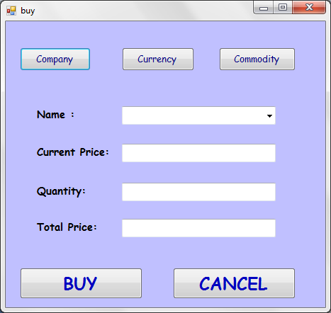

Imports System.Data.SqlClient

Public Class buy
Dim myconn As SqlConnection
Dim mycom As SqlCommand
Dim name1 As String
Dim mycom1 As SqlCommand
Dim mycom2 As SqlCommand
Dim mycom3 As SqlCommand
Dim mycom5 As SqlCommand
Dim mycom4 As SqlCommand
Dim dr As SqlDataReader

Private Sub Button5_Click(ByVal sender As System.Object, ByVal e As System.EventArgs) Handles Button5.Click
Me.Hide()
memdata.Show()

End Sub

Private Sub ComboBox1_SelectedIndexChanged(ByVal sender As System.Object, ByVal e As System.EventArgs) Handles ComboBox1.SelectedIndexChanged
Try
myconn = New SqlConnection("Data Source=.;AttachDbFilename=C:\Program Files (x86)\Microsoft SQL Server\MSSQL10_50.MSSQLSERVER\MSSQL\DATA\stockmarket.mdf;Integrated Security=True;Connect Timeout=30;User Instance=True")
myconn.Open()
If (name1 = "company") Then
mycom = New SqlCommand("select curr_price from company where comp_name='" & ComboBox1.Text & "'", myconn)
dr = mycom.ExecuteReader()
If (dr.Read) Then
TextBox1.Text = dr.Item("curr_price")
End If
dr.Close()
End If
If (name1 = "currency") Then
mycom = New SqlCommand("select cprice from currency where cname='" & ComboBox1.Text & "'", myconn)
dr = mycom.ExecuteReader()
If (dr.Read) Then
TextBox1.Text = dr.Item("cprice")
End If
dr.Close()
End If
If (name1 = "commodity") Then
mycom = New SqlCommand("select cmprice from commodity where cmname='" & ComboBox1.Text & "'", myconn)
dr = mycom.ExecuteReader()
If (dr.Read) Then
TextBox1.Text = dr.Item("cmprice")
End If
dr.Close()
End If
Catch ex As Exception

End Try
End Sub

Private Sub Button1_Click(ByVal sender As System.Object, ByVal e As System.EventArgs) Handles Button1.Click
Try
myconn = New SqlConnection("Data Source=.;AttachDbFilename=C:\Program Files (x86)\Microsoft SQL Server\MSSQL10_50.MSSQLSERVER\MSSQL\DATA\stockmarket.mdf;Integrated Security=True;Connect Timeout=30;User Instance=True")
myconn.Open()
name1 = "company"
mycom = New SqlCommand("select comp_name from company", myconn)
dr = mycom.ExecuteReader()
While (dr.Read)
ComboBox1.Items.Add(dr.Item("comp_name"))

End While
dr.Close()
myconn.Close()
Catch ex As Exception

End Try
End Sub

Private Sub Button2_Click(ByVal sender As System.Object, ByVal e As System.EventArgs) Handles Button2.Click
Try
myconn = New SqlConnection("Data Source=.;AttachDbFilename=C:\Program Files (x86)\Microsoft SQL Server\MSSQL10_50.MSSQLSERVER\MSSQL\DATA\stockmarket.mdf;Integrated Security=True;Connect Timeout=30;User Instance=True")
myconn.Open()
name1 = "currency"
mycom = New SqlCommand("select cname from currency", myconn)
dr = mycom.ExecuteReader()
While (dr.Read)
ComboBox1.Items.Add(dr.Item("cname"))

End While
dr.Close()
myconn.Close()

Catch ex As Exception

End Try
End Sub

Private Sub Button3_Click(ByVal sender As System.Object, ByVal e As System.EventArgs) Handles Button3.Click

Try

myconn = New SqlConnection("Data Source=.;AttachDbFilename=C:\Program Files (x86)\Microsoft SQL Server\MSSQL10_50.MSSQLSERVER\MSSQL\DATA\stockmarket.mdf;Integrated Security=True;Connect Timeout=30;User Instance=True")
myconn.Open()
name1 = "commodity"
mycom = New SqlCommand("select cmname from commodity", myconn)
dr = mycom.ExecuteReader()
While (dr.Read)
ComboBox1.Items.Add(dr.Item("cmname"))

End While
dr.Close()
myconn.Close()
Catch ex As Exception

End Try
End Sub

Private Sub TextBox2_TextChanged(ByVal sender As System.Object, ByVal e As System.EventArgs) Handles TextBox2.TextChanged
TextBox3.Text = TextBox1.Text * TextBox2.Text
End Sub

Private Sub Button4_Click(ByVal sender As System.Object, ByVal e As System.EventArgs) Handles Button4.Click
Try
Dim unit As String
Dim balance As Double
unit = "kg"
balance = 0
myconn = New SqlConnection("Data Source=.;AttachDbFilename=C:\Program Files (x86)\Microsoft SQL Server\MSSQL10_50.MSSQLSERVER\MSSQL\DATA\stockmarket.mdf;Integrated Security=True;Connect Timeout=30;User Instance=True")
myconn.Open()
mycom2 = New SqlCommand("select balance from member where mname='" & memdata.username.Text & "'", myconn)
dr = mycom2.ExecuteReader()
If (dr.Read) Then
balance = dr.Item("balance")
End If
dr.Close()

Dim mid As Integer
mid = 0

mycom2 = New SqlCommand("select mid from member where mname='" & memdata.username.Text & "'", myconn)
dr = mycom2.ExecuteReader()
If (dr.Read) Then
mid = dr.Item("mid")
End If
dr.Close()

Dim bal As Double
bal = balance - TextBox3.Text
If (bal <= 0) Then
MsgBox("NOT SUFFICIENT BALANCE")
Else

If (name1 = "commodity") Then
mycom = New SqlCommand("select unit from commodity where cmname='" & ComboBox1.Text & "'", myconn)
dr = mycom.ExecuteReader()
If (dr.Read) Then
unit = dr.Item("unit")
End If
dr.Close()
mycom1 = New SqlCommand("insert into member_commodity values ('" & mid & "','" & ComboBox1.Text & " ', '" & TextBox1.Text & " ','" & TextBox1.Text & " ','" & TextBox2.Text & " ','" & unit & " ',0.0,0.0)", myconn)
mycom1.ExecuteNonQuery()

End If
If (name1 = "currency") Then
mycom3 = New SqlCommand("insert into member_currency values ('" & mid & "','" & ComboBox1.Text & " ', '" & TextBox1.Text & " ','" & TextBox2.Text & " ','" & TextBox1.Text & " ',0.0,0.0)", myconn)
mycom3.ExecuteNonQuery()
End If
If (name1 = "company") Then
mycom4 = New SqlCommand("insert into shares values ('" & mid & "','" & ComboBox1.Text & " ', '" & TextBox1.Text & " ','" & TextBox1.Text & " ','" & TextBox2.Text & " ',0.0,0.0)", myconn)
mycom4.ExecuteNonQuery()
End If
mycom5 = New SqlCommand("update member set balance='" & bal & "'where mname='" & memdata.username.Text & "'", myconn)
mycom5.ExecuteNonQuery()
MsgBox("SHARE ADDED")
Me.Hide()
memdata.Show()

End If

myconn.Close()
Catch ex As Exception
MsgBox("ERROR: " + ex.Message)
End Try
End Sub

Private Sub buy_Load(ByVal sender As System.Object, ByVal e As System.EventArgs) Handles MyBase.Load

End Sub
End Class

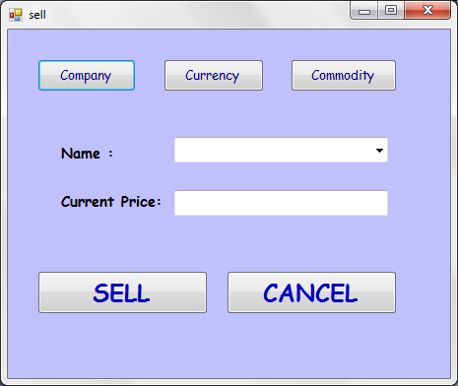

Imports System.Data.SqlClient

Public Class sell
Dim myconn As SqlConnection
Dim mycom As SqlCommand
Dim name1 As String
Dim mycom1 As SqlCommand
Dim mycom2 As SqlCommand
Dim mycom3 As SqlCommand
Dim dr As SqlDataReader

Private Sub Button5_Click(ByVal sender As System.Object, ByVal e As System.EventArgs) Handles Button5.Click
Me.Hide()
memdata.Show()

End Sub

Private Sub Button1_Click(ByVal sender As System.Object, ByVal e As System.EventArgs) Handles Button1.Click
Try
myconn = New SqlConnection("Data Source=.;AttachDbFilename=C:\Program Files (x86)\Microsoft SQL Server\MSSQL10_50.MSSQLSERVER\MSSQL\DATA\stockmarket.mdf;Integrated Security=True;Connect Timeout=30;User Instance=True")
myconn.Open()
name1 = "company"
Dim mid As Integer
mid = 0

mycom1 = New SqlCommand("select mid from member where mname='" & memdata.username.Text & "'", myconn)
dr = mycom1.ExecuteReader()
If (dr.Read) Then
mid = dr.Item("mid")
End If
dr.Close()
mycom = New SqlCommand("select comp_name from shares where mid='" & mid & "'", myconn)
dr = mycom.ExecuteReader()
While (dr.Read)
ComboBox1.Items.Add(dr.Item("comp_name"))

End While
dr.Close()
myconn.Close()
Catch ex As Exception

End Try
End Sub

Private Sub Button2_Click(ByVal sender As System.Object, ByVal e As System.EventArgs) Handles Button2.Click
Try
myconn = New SqlConnection("Data Source=.;AttachDbFilename=C:\Program Files (x86)\Microsoft SQL Server\MSSQL10_50.MSSQLSERVER\MSSQL\DATA\stockmarket.mdf;Integrated Security=True;Connect Timeout=30;User Instance=True")
myconn.Open()
Dim mid As Integer
mid = 0

mycom1 = New SqlCommand("select mid from member where mname='" & memdata.username.Text & "'", myconn)
dr = mycom1.ExecuteReader()
If (dr.Read) Then
mid = dr.Item("mid")
End If
dr.Close()
name1 = "currency"
mycom = New SqlCommand("select cname from member_currency where mid='" & mid & "'", myconn)
dr = mycom.ExecuteReader()
While (dr.Read)
ComboBox1.Items.Add(dr.Item("cname"))

End While
dr.Close()
myconn.Close()
Catch ex As Exception

End Try
End Sub

Private Sub Button3_Click(ByVal sender As System.Object, ByVal e As System.EventArgs) Handles Button3.Click
Try

myconn = New SqlConnection("Data Source=.;AttachDbFilename=C:\Program Files (x86)\Microsoft SQL Server\MSSQL10_50.MSSQLSERVER\MSSQL\DATA\stockmarket.mdf;Integrated Security=True;Connect Timeout=30;User Instance=True")
myconn.Open()
name1 = "commodity"
Dim mid As Integer
mid = 0

mycom1 = New SqlCommand("select mid from member where mname='" & memdata.username.Text & "'", myconn)
dr = mycom1.ExecuteReader()
If (dr.Read) Then
mid = dr.Item("mid")
End If
dr.Close()
mycom = New SqlCommand("select cmname from member_commodity where mid='" & mid & "'", myconn)
dr = mycom.ExecuteReader()
While (dr.Read)
ComboBox1.Items.Add(dr.Item("cmname"))

End While
dr.Close()
myconn.Close()
Catch ex As Exception

End Try
End Sub

Private Sub ComboBox1_SelectedIndexChanged(ByVal sender As System.Object, ByVal e As System.EventArgs) Handles ComboBox1.SelectedIndexChanged
Try
myconn = New SqlConnection("Data Source=.;AttachDbFilename=C:\Program Files (x86)\Microsoft SQL Server\MSSQL10_50.MSSQLSERVER\MSSQL\DATA\stockmarket.mdf;Integrated Security=True;Connect Timeout=30;User Instance=True")
myconn.Open()
If (name1 = "company") Then
mycom = New SqlCommand("select curr_price from company where comp_name='" & ComboBox1.Text & "'", myconn)
dr = mycom.ExecuteReader()
If (dr.Read) Then
TextBox1.Text = dr.Item("curr_price")
End If
dr.Close()

End If
If (name1 = "currency") Then
mycom = New SqlCommand("select cprice from currency where cname='" & ComboBox1.Text & "'", myconn)
dr = mycom.ExecuteReader()
If (dr.Read) Then
TextBox1.Text = dr.Item("cprice")
End If
dr.Close()

End If
If (name1 = "commodity") Then
mycom = New SqlCommand("select cmprice from commodity where cmname='" & ComboBox1.Text & "'", myconn)
dr = mycom.ExecuteReader()
If (dr.Read) Then
TextBox1.Text = dr.Item("cmprice")
End If
dr.Close()

End If

Catch ex As Exception
End Try
End Sub

Private Sub Button4_Click(ByVal sender As System.Object, ByVal e As System.EventArgs) Handles Button4.Click
Try
myconn = New SqlConnection("Data Source=.;AttachDbFilename=C:\Program Files (x86)\Microsoft SQL Server\MSSQL10_50.MSSQLSERVER\MSSQL\DATA\stockmarket.mdf;Integrated Security=True;Connect Timeout=30;User Instance=True")
myconn.Open()
Dim quantity As Integer
quantity = 0
Dim dbBalance As Integer
dbBalance = 0
Dim mid As Integer
mid = 0

mycom1 = New SqlCommand("select mid from member where mname='" & memdata.username.Text & "'", myconn)
dr = mycom1.ExecuteReader()
If (dr.Read) Then
mid = dr.Item("mid")
End If
dr.Close()
If (name1 = "commodity") Then
mycom = New SqlCommand("select quantity from member_commodity where cmname='" & ComboBox1.Text & "' and mid='" & mid & "'", myconn)
dr = mycom.ExecuteReader()
If (dr.Read) Then
quantity= dr.Item("quantity")
End If
dr.Close()
mycom = New SqlCommand("delete from member_commodity where cmname='" & ComboBox1.Text & "' and mid='" & mid & "'", myconn)
mycom.ExecuteNonQuery()
End If
If (name1 = "currency") Then

mycom = New SqlCommand("select quantity from member_currency where cname='" & ComboBox1.Text & "' and mid='" & mid & "'", myconn)
dr = mycom.ExecuteReader()
If (dr.Read) Then
quantity = dr.Item("quantity")
End If
dr.Close()
mycom = New SqlCommand("delete from member_currency where cname='" & ComboBox1.Text & "' and mid='" & mid & "'", myconn)
mycom.ExecuteNonQuery()
End If
If (name1 = "company") Then
mycom = New SqlCommand("select quantity from shares where comp_name ='" & ComboBox1.Text & "' and mid='" & mid & "'", myconn)
dr = mycom.ExecuteReader()
If (dr.Read) Then
quantity = dr.Item("quantity")
End If
dr.Close()
mycom = New SqlCommand("delete from shares where comp_name='" & ComboBox1.Text & "' and mid='" & mid & "'", myconn)
mycom.ExecuteNonQuery()
End If

Dim balance As String
balance = quantity * TextBox1.Text

mycom2 = New SqlCommand("select balance from member where mid='" & mid & "'", myconn)
dr = mycom2.ExecuteReader()
If (dr.Read) Then
dbBalance = dr.Item("balance")
End If
dr.Close()
balance = balance + dbBalance

mycom3 = New SqlCommand("update member set balance='" & balance & "' where mid='" & mid & "'", myconn)
mycom3.ExecuteNonQuery()
MsgBox("SHARE DELETED")
Me.Hide()
memdata.Show()

Catch ex As Exception
End Try

End Sub
End Class

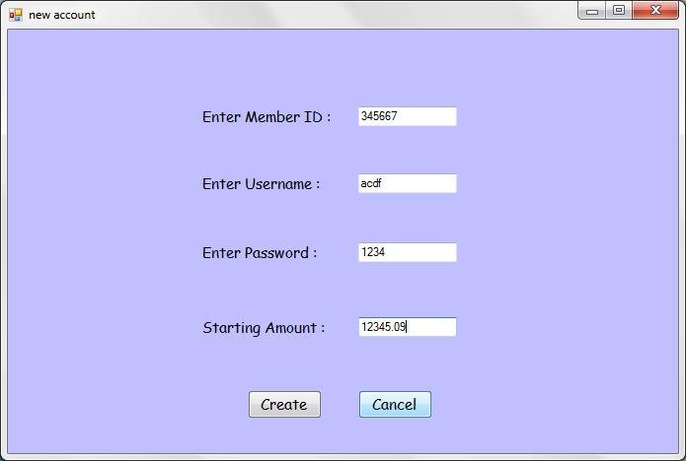

Imports System.Data.SqlClient

Public Class add_acc
Dim myconn As SqlConnection
Dim mycom As SqlCommand
Dim mycom1 As SqlCommand
Dim dr As SqlDataReader
Private Sub Label4_Click(ByVal sender As System.Object, ByVal e As System.EventArgs) Handles Label4.Click

End Sub

Private Sub Button1_Click(ByVal sender As System.Object, ByVal e As System.EventArgs) Handles Button1.Click
Try
myconn = New SqlConnection("Data Source=.;AttachDbFilename=C:\Program Files (x86)\Microsoft SQL Server\MSSQL10_50.MSSQLSERVER\MSSQL\DATA\stockmarket.mdf;Integrated Security=True;Connect Timeout=30;User Instance=True")
myconn.Open()
mycom1 = New SqlCommand("insert into member values ('" & TextBox1.Text & "','" & TextBox2.Text & " ', '" & TextBox3.Text & " ','" & TextBox4.Text & " ')", myconn)
mycom1.ExecuteNonQuery()
MsgBox("ACCOUNT ADDED")
myconn.Close()
Catch ex As Exception
End Try
Me.Hide()
memdata.Show()
End Sub

Private Sub Button2_Click(ByVal sender As System.Object, ByVal e As System.EventArgs) Handles Button2.Click
Me.Hide()
memlogin.Show()

End Sub
End Class

BACK END
create database stockmarket

create table member
(
mid int,
mname varchar(20),
pass varchar(10),
balance numeric(20,5),
primary key(mid)
);

create table currency
(
cname varchar(20),
cprice float(2),
oprice float(2),
diff float(2),
primary key(cname,cprice)
);

create table member_currency
(
mid int ,
cname varchar(20),
cprice float(2),
quantity int,
invest_amt float(2),
gain float(2),
tgain float(2),
foreign key(mid) references member
on update cascade
on delete cascade,
foreign key(cname,cprice) references currency
on update cascade
on delete cascade
);

create table commodity
(
cmname varchar(20),
cmprice float(2),
oprice float(2),
diff float(2),
unit varchar(10),
primary key(cmname,cmprice,unit)
);

create table member_commodity
(
mid int,
cmname varchar(20),
cmprice float(2),
invest_amt float(2),
quantity int,
unit varchar(10),
gain float(2),
tgain float(2),
foreign key(mid) references member
on update cascade
on delete cascade,
foreign key(cmname,cmprice,unit) references commodity
on update cascade
on delete cascade
);

create table company
(
comp_name varchar(50),
industry varchar(50),
tshares int,
curr_price float(2),
old_price float(2),
diff float(2),
avail_shares int,
product numeric(15,4),
primary key(comp_name,curr_price)
);

create table shares
(
mid int,
comp_name varchar(50),
curr_price float(2),
invest_amt float(2),
quantity int,
gain float(2),
tgain float(2),
foreign key(mid) references member
on update cascade
on delete cascade,
foreign key(comp_name,curr_price) references company
on update cascade
on delete cascade
);

create table administrator
(
admin_name varchar(20),
admin_pass varchar(10),
primary key(admin_name)
);

insert into member values (11111, 'Prajakta Shinde','abc',100000.00);
insert into member values (22222, 'Hiral Shah','123',50000.00);

insert into currency values ('US $/Rupee',55.2,0.0,0.0);
insert into currency values ('Euros/Rupee',69.4,0.0,0.0);
insert into currency values ('AUS $/Rupee',52.72,0.0,0.0);
insert into currency values ('Japenese yen/Rupee',0.62,0.0,0.0);
insert into currency values ('Renminbi/Rupee',8.12,0.0,0.0);
insert into currency values ('Pounds/Pupee',85.8,0.0,0.0);
insert into currency values ('Dirhams/Rupee',14.00,0.0,0.0);
insert into currency values ('singapore $/Rupee',43.77,0.0,0.0);
insert into currency values ('Taiwan $/Rupee',1.82,0.0,0.0);
insert into currency values ('Ringgit/Rupee',15.67,0.0,0.0);

insert into commodity values ('Gold',28345.62,0.0,0.0,'10 gm');
insert into commodity values ('Silver',55500.2,0.0,0.0,'kg');
insert into commodity values ('Crudeoil',5237,0.0,0.0,'barrel');
insert into commodity values ('Copper',435.5,0.0,0.0,'kg');
insert into commodity values ('Zinc',102.10,0.0,0.0,'kg');
insert into commodity values ('Lead',113.69,0.0,0.0,'kg');
insert into commodity values ('Nickel',910.45,0.0,0.0,'kg');
insert into commodity values ('Aluminium',106.80,0.0,0.0,'kg');
insert into commodity values ('Natural Gas',194.80,0.0,0.0,'kg');
insert into commodity values ('Cotton',16790.65,0.0,0.0,'kg');

insert into company values('Cipla','Pharmaceuticals', 56000, 105.25,0.0,0.0,40000,0.0);
insert into company values('Wipro','Information Technology', 100000, 65.23,0.0,0.0,80000,0.0);
insert into company values('ICICI Bank','Banking',70000,362.14,0.0,0.0,60000,0.0);
insert into company values('Mahindra & Mahindra','Automotive', 60000, 203.16,0.0,0.0,45000,0.0);
insert into company values('Tata Power','Power', 20000, 70.36,0.0,0.0,10000,0.0);
insert into company values('Reliance Industries','Oil and gas', 90000, 513.64,0.0,0.0,75000,0.0);
insert into company values('DLF','Real estate',65000,220.5,0.0,0.0,50000,0.0);
insert into company values('Sterlite Industries','Metals and Mining', 80000, 80.45,0.0,0.0,62000,0.0);
insert into company values('Infosys','Information Technology', 75000, 110.89,0.0,0.0,58000,0.0);
insert into company values('Bharti Airtel','Telecommunication', 50000, 1050.21,0.0,0.0,43000,0.0);
insert into company values('State Bank Of India','Banking', 32000, 165.91,0.0,0.0,25000,0.0);
insert into company values('Oil and Natural Gas Corporation','Oil and gas', 30000, 60.95,0.0,0.0,20000,0.0);
insert into company values('Jindal Steel & Power','Steel & Power', 75000, 254.123,0.0,0.0,64000,0.0);
insert into company values('Maruti Suzuki','Automotive', 85000, 756.46,0.0,0.0,72000,0.0);
insert into company values('Hindustan Unilever','Consumer goods', 45000, 564.78,0.0,0.0,31000,0.0);

UPDATE company
SET product=avail_shares*curr_price;

select * from company;

CREATE VIEW comp
AS
SELECT comp_name,industry,avail_shares,curr_price,diff
FROM company;

select * from comp;

insert into member_currency values(11111,'AUS $/Rupee', 52.72, 50, 50.32, 0, 0);
insert into member_currency values(11111,'US $/Rupee', 55.2, 50, 58.56, 0, 0);
insert into member_currency values(11111,'Ringgit/Rupee', 15.67, 50, 16.75, 0, 0);

insert into member_currency values(22222,'AUS $/Rupee', 52.72, 50, 53.58, 0, 0);
insert into member_currency values(22222,'Pounds/Pupee', 85.8, 75, 86.68, 0, 0);
insert into member_currency values(22222,'Ringgit/Rupee', 15.67,80, 14.77, 0, 0);

insert into member_commodity values(11111,'Gold', 28345.62, 27468.32, 7,'10 gm', 0, 0);
insert into member_commodity values(11111,'Copper', 435.5, 440.3, 5,'kg', 0, 0);

insert into member_commodity values(22222,'Silver', 55500.2, 55515.66, 0.5,'kg', 0, 0);
insert into member_commodity values(22222,'Cotton', 16790.65, 15398.52, 3,'kg', 0, 0);

insert into shares values(11111,'Wipro', 65.23, 68.8, 100, 0, 0);
insert into shares values(11111,'Cipla', 105.25, 106.43, 80, 0, 0);
insert into shares values(11111,'DLF', 220.5, 218.94, 25, 0, 0);
insert into shares values(11111,'ICICI Bank', 362.14, 363, 50, 0, 0);
insert into shares values(11111,'Infosys', 110.89, 109.3, 60, 0, 0);
insert into shares values(11111,'Mahindra & Mahindra', 203.16, 200.9, 45,0, 0);
insert into shares values(11111,'Reliance Industries', 513.64, 513.1, 105, 0, 0);

insert into shares values(22222,'Bharti Airtel', 1050.21, 1045.3, 40, 0, 0);
insert into shares values(22222,'Wipro', 65.23, 66.8,90, 0, 0);
insert into shares values(22222,'Jindal Steel & Power', 254.123, 255, 60, 0, 0);
insert into shares values(22222,'Maruti Suzuki', 756.46, 755.4, 50, 0, 0);
insert into shares values(22222,'Hindustan Unilever', 564.78, 564.3, 30, 0, 0);
insert into shares values(22222,'Tata Power', 70.36, 69.8, 100, 0, 0);

insert into administrator values('rajmehta123','777');

update member_currency
set gain=cprice-invest_amt;

update member_currency
set tgain=gain*quantity;

update member_commodity
set gain=cmprice-invest_amt;

update member_commodity
set tgain=gain*quantity;

update shares
set gain=curr_price-invest_amt;

update shares
set tgain=gain*quantity;

